1. *Introduction of the Assignment*

The application that I want creates for this assignment is about ‘ThinkTrek_Grade.My’ application. This application was specially designed for the user. This application can only be access by the lecturer and student whom has their own mark to check their grade at the university.

* Introduction about the student grades itself, including the mark and the grade that provided by the University.
* Application that can help the student to check their own grade.
* Application that are suitable to be access by anyone at the university if their have the mark to be converted to grades.

1. *Application Background*

The application that has been created can be considered as friendly user because the application is simple, complete with sufficient information and easier uses it. This application can be access by the students at the university. This system was developed in order to perform a simple system for the user (especially students).This application is designed in such way to enable the students to view and check their grades properly. At the same time, by using this application they (students) does not need to calculate the grades in manual way.

This application is simple and the user would feel comfortable when using this application. Furthermore, it helps to convert mark to grades properly that are included in this application. It also helps the students to find out how many grades in order at certain time by using this application. This application can display grades. At the same time, it helps the students know details about grades when insert their mark and this application will calculate the grades correctly. Hence, the user (students) does not need to use manual way, for example calculator.

*3.0 Implementation*

In this ‘ThinkTrek_Grade.My’, I will describe on implementation process of the Student Grades application. The main purpose is to convert from mark to grades and also display the result grades application online. I will brief about design interfaces and structure to develop of this application.

***3.1 System Structure***

Development this application consists two main structures. There are:

1. Interface Design
2. Coding Development
3. **Interface Design**

The effectiveness and consistently application is the most important thing should we concerned. Good presented functionally is a right way how to make user convenience when use it. Interface of the application is just addition value to attract the user.

1. **Coding Development**

Process of designing, writing, testing, and maintaining the source code of application programs. Designing interface and functional of application using Microsoft Visual Studio 2010 .

***3.2 Interface Design and Function of Application***

***[HOME PAGE]***

When the students enter this application, it will show the Home Page Interface.This is the home page of ThinkTrek_Grade.My Application. The interface is look quite simple interface but it easy to apply this function. Students can views all the information about academic and regulation scheme. Two Navigation Bar is provided at the above of this page to describe the function of the application. 2 Navigation Bar are Home page, and Lets Check.

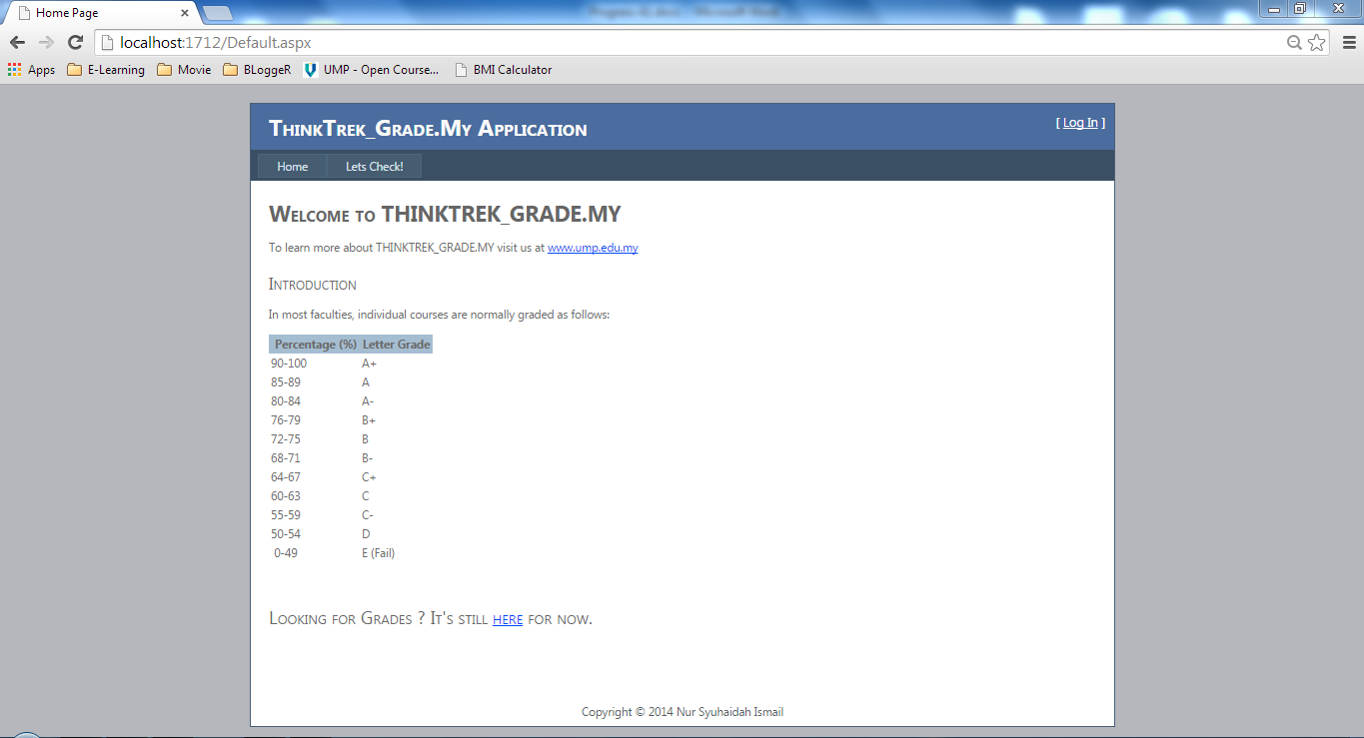

Hyperlink Text

Footer

Header

2 Navigation Bar

View Academic Grades Information

**Figure 3.2 (a)**

***[LETS CHECK]***

This page is about calculating grades that can view by students. The textbox is used to insert all the data needed and also display the result output. Meanwhile, button that show have 3 categories, there are Calculate button, Refresh button and lastly Exit button. Calculate button work as calculating student mark into grades while Refresh button is used to clear the textbox.

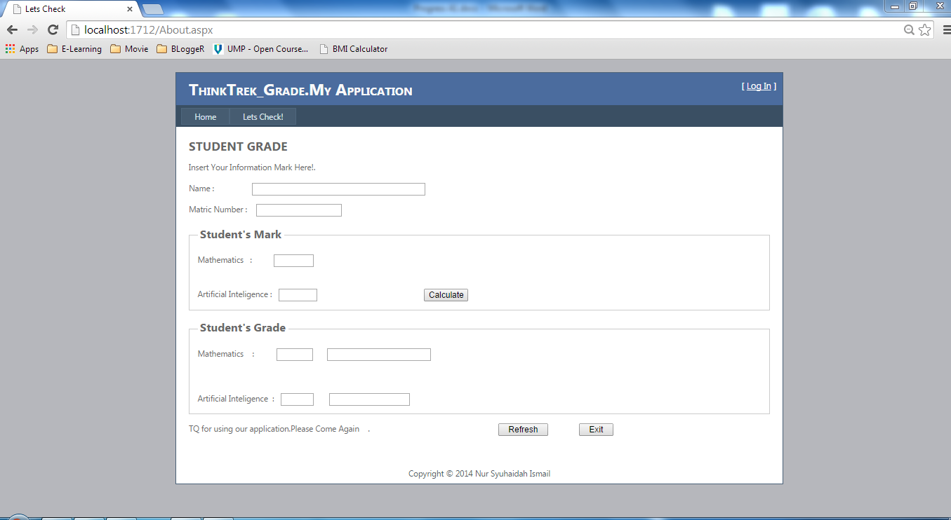

Textbox2

Textbox1

Textbox6

Textbox8

Textbox5

Textbox7

Textbox4

Textbox3

Button2

Button3

Button1

Footer

Header

**Figure 3.2 (b)**

***[FINAL RESULT]***

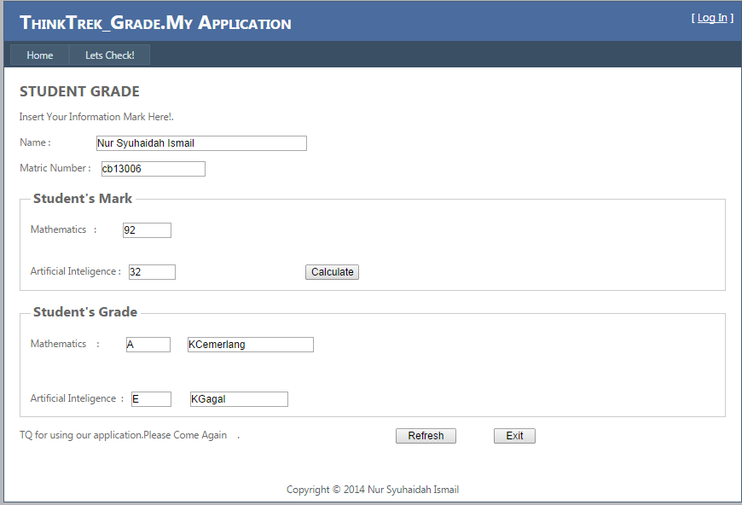

Student Grades will display either result is A,B,C,D or Fail

Student are should Insert their Mark

**Figure 3.2 (c)**

***3.3 Coding Development***

**[Coding 1] Home Page**

<h2 style="font-size: x-large; font-weight: bold">

Welcome to THINKTREK_GRADE.MY

</h2>

<p>

To learn more about THINKTREK_GRADE.MY visit us at <a href="http://www.ump.edu.my" title="UMP Website">www.ump.edu.my</a>

</p>

<h2>

Introduction</h2>

<a name="217"></a>

<p>

In most faculties, individual courses are normally graded as follows:</p>

<a name="218"></a>

<p>

</p>

<table cellpadding="3" cellspacing="1">

<tr valign="top">

<th style="background-color:#a5bdd1;">

&nbsp;Percentage (%)

</th>

<th style="background-color:#a5bdd1;">

Letter Grade

</th>

</tr>

<tr valign="top">

<td>

90-100

</td>

<td>

A+

</td>

</tr>

<tr valign="top">

<td>

85-89

</td>

<td>

A

</td>

</tr>

<tr valign="top">

<td>

80-84

</td>

<td>

A-

</td>

</tr>

<tr valign="top">

<td>

76-79

</td>

<td>

B+

</td>

</tr>

<tr valign="top">

<td>

72-75

</td>

<td>

B

</td>

</tr>

<tr valign="top">

<td>

68-71

</td>

<td>

B-

</td>

</tr>

<tr valign="top">

<td>

64-67

</td>

<td>

C+

</td>

</tr>

<tr valign="top">

<td>

60-63

</td>

<td>

C

</td>

</tr>

<tr valign="top">

<td>

55-59

</td>

<td>

C-

</td>

</tr>

<tr valign="top">

<td>

50-54

</td>

<td>

D

</td>

</tr>

<tr valign="top">

<td>

&nbsp;0-49

</td>

<td>

E (Fail)

</td>

</tr>

</table>

<p>

&nbsp;</p>

<h1 class="gradessubtitle">

Looking for Grades ? It&#39;s still

<a href="http://localhost:1712/About.aspx">here</a> for

now.</h1>

<p>

&nbsp;</p>

<p>

&nbsp;</p>

<div class="footer" id="footer">

<center>Copyright © 2014 Nur Syuhaidah Ismail</center></div>

</asp:Content>

**[Coding 2] Lets Check**

<h2 style="font-weight: bold">

STUDENT GRADE</h2>

<p>

Insert Your Information Mark Here!.

</p>

<p>

Name :&nbsp;&nbsp;&nbsp;&nbsp;&nbsp;&nbsp;&nbsp;&nbsp;&nbsp;&nbsp;&nbsp;&nbsp;&nbsp;&nbsp;&nbsp;&nbsp;

<asp:TextBox ID="TextBox1" runat="server" Width="272px"></asp:TextBox>

</p>

<p>

Matric Number :&nbsp;&nbsp;&nbsp;

<asp:TextBox ID="TextBox2" runat="server" Width="134px"></asp:TextBox>

</p>

<fieldset class="web1">

<legend style="font-size: large; font-weight: bold">Student's Mark</legend>

<div>Mathematics&nbsp;&nbsp; :&nbsp;&nbsp;&nbsp;&nbsp;&nbsp;&nbsp;&nbsp;&nbsp;&nbsp;

<asp:TextBox ID="TextBox3" runat="server" Width="61px"></asp:TextBox>

<br />

<br />

<br />

Artificial Inteligence :&nbsp;&nbsp;

<asp:TextBox ID="TextBox4" runat="server" Width="59px"></asp:TextBox>

&nbsp;&nbsp;&nbsp;&nbsp;&nbsp;&nbsp;&nbsp;&nbsp;&nbsp;&nbsp;&nbsp;&nbsp;&nbsp;&nbsp;&nbsp;&nbsp;&nbsp;&nbsp;&nbsp;&nbsp;&nbsp;&nbsp;&nbsp;&nbsp;&nbsp;&nbsp;&nbsp;&nbsp;&nbsp;&nbsp;&nbsp;&nbsp;&nbsp;&nbsp;&nbsp;&nbsp;&nbsp;&nbsp;&nbsp;&nbsp;&nbsp;&nbsp;&nbsp;&nbsp;&nbsp;&nbsp;

<asp:Button ID="Button1" runat="server" Text="Calculate" />

</div>

</fieldset>

<fieldset class="web2">

<legend style="font-size: large; font-weight: bold">Student's Grade</legend>

Mathematics&nbsp;&nbsp;&nbsp; :&nbsp;&nbsp;&nbsp;&nbsp;&nbsp;&nbsp;&nbsp;&nbsp;&nbsp;

<asp:TextBox ID="TextBox5" runat="server" Width="56px"></asp:TextBox>

&nbsp;&nbsp;&nbsp;&nbsp;

<asp:TextBox ID="TextBox7" runat="server"></asp:TextBox>

<br />

<br />

<br />

<br />

Artificial Inteligence&nbsp; :&nbsp;&nbsp;

<asp:TextBox ID="TextBox6" runat="server" Width="50px"></asp:TextBox>

&nbsp;&nbsp;&nbsp;&nbsp;&nbsp;

<asp:TextBox ID="TextBox8" runat="server" Width="125px"></asp:TextBox>

&nbsp;&nbsp;&nbsp;&nbsp;&nbsp;

<br />

</fieldset>

<p>

TQ for using our application.Please Come Again&nbsp;&nbsp;&nbsp; .&nbsp;&nbsp;&nbsp;&nbsp;&nbsp;&nbsp;&nbsp;&nbsp;&nbsp;&nbsp;&nbsp;&nbsp;&nbsp;&nbsp;&nbsp;&nbsp;&nbsp;&nbsp;&nbsp;&nbsp;&nbsp;&nbsp;&nbsp;&nbsp;&nbsp;&nbsp;&nbsp;&nbsp;&nbsp;&nbsp;&nbsp;&nbsp;&nbsp;&nbsp;&nbsp;&nbsp;&nbsp;&nbsp;&nbsp;&nbsp;&nbsp;&nbsp;&nbsp;&nbsp;&nbsp;&nbsp;&nbsp;&nbsp;&nbsp;&nbsp;&nbsp;&nbsp;&nbsp;&nbsp;&nbsp;&nbsp;&nbsp;

<asp:Button ID="Button2" runat="server" Text="Refresh" Width="79px" />

&nbsp;&nbsp;&nbsp;&nbsp;&nbsp;&nbsp;&nbsp;&nbsp;&nbsp;&nbsp; &nbsp;

<asp:Button ID="Button3" runat="server" Text="Exit" Width="54px" />

</p>

<p>

&nbsp;</p>

<div class="footer" id="footer">

<center>Copyright © 2014 Nur Syuhaidah Ismail</center></div>

</asp:Content>

**[Coding 3] Calculate Button**

Protected Sub Button1_Click(ByVal sender As Object, ByVal e As EventArgs) Handles Button1.Click

Dim num1, num2 As Single

num1 = CDbl(TextBox3.Text)

num2 = CDbl(TextBox4.Text)

If num1 >= 80 Then

TextBox5.Text = "A"

TextBox7.Text = "KCemerlang"

ElseIf num1 < 80 And num1 >= 75 Then

TextBox5.Text = "A-"

TextBox7.Text = "KCemerlang"

ElseIf num1 < 75 And num1 >= 70 Then

TextBox5.Text = "B+"

TextBox7.Text = "KBaik"

ElseIf num1 < 70 And num1 >= 60 Then

TextBox5.Text = "B"

TextBox7.Text = "KBaik"

ElseIf num1 < 69 And num1 >= 61 Then

TextBox5.Text = "C+"

TextBox7.Text = "KBaik"

ElseIf num1 < 62 And num1 >= 55 Then

TextBox5.Text = "C"

TextBox7.Text = "KBaik"

ElseIf num1 < 55 And num1 >= 50 Then

TextBox5.Text = "D"

TextBox7.Text = "KLulus"

ElseIf num1 < 50 Then

TextBox5.Text = "E"

TextBox7.Text = "KGagal"

End If

If num2 >= 80 Then

TextBox6.Text = "A"

TextBox8.Text = "KCemerlang"

ElseIf num2 < 80 And num2 >= 75 Then

TextBox6.Text = "A-"

TextBox8.Text = "KCemerlang"

ElseIf num2 < 75 And num2 >= 70 Then

TextBox6.Text = "B+"

TextBox8.Text = "KBaik"

ElseIf num2 < 70 And num2 >= 60 Then

TextBox6.Text = "B"

TextBox8.Text = "KBaik"

ElseIf num2 < 69 And num2 >= 61 Then

TextBox6.Text = "C+"

TextBox8.Text = "KBaik"

ElseIf num2 < 62 And num1 >= 55 Then

TextBox6.Text = "C"

TextBox8.Text = "KBaik"

ElseIf num2 < 55 And num2 >= 50 Then

TextBox6.Text = "D"

TextBox8.Text = "KLulus"

ElseIf num2 < 50 Then

TextBox6.Text = "E"

TextBox8.Text = "KGagal"

End If

End If

End Sub

Protected Sub Button3_Click(ByVal sender As Object, ByVal e As EventArgs) Handles Button3.Click

Dim warning As String

warning = MsgBox("Are you sure to exit the system?", MsgBoxStyle.YesNo, "Exit System")

If warning = vbYes Then

End If

End Sub

Protected Sub Button2_Click(ByVal sender As Object, ByVal e As EventArgs) Handles Button2.Click

TextBox1.Text = " "

TextBox2.Text = " "

TextBox3.Text = " "

TextBox4.Text = " "

TextBox5.Text = " "

TextBox6.Text = " "

TextBox7.Text = " "

TextBox8.Text = " "

End Sub

End Class

1. *References*

[1] Additional advice and supportive materials for ThinkTrek_Grade.My Application.

Dr Qin HongWu

System Computer and Software Engineering Faculty [FSKKP].

[2] Academic Guide & Regulation

[www.ump.edu.my/en/publications/others/academicguide-regulations](http://www.ump.edu.my/en/publications/others/academicguide-regulations)

[3] Asp.Net Resource : <http://stackoverflow.com/questions/13097356/groupbox-not-intoolbox>

# [4] Create a Web Site using Visual Studio 2010 :

# <http://www.youtube.com/watch?v=gTgkdNkMr8I>

[5] Deploying an Asp.Net Web Application using Visual Studio by Tom Dykstra [Microsoft]

[6] Source code W3School (PHP code)

URL: <http://www.w3schools.com/>

[7] Video tutorial PHP

URL: <http://www.web3mantra.com/2011/06/21/35-best-php-video-tutorials/>